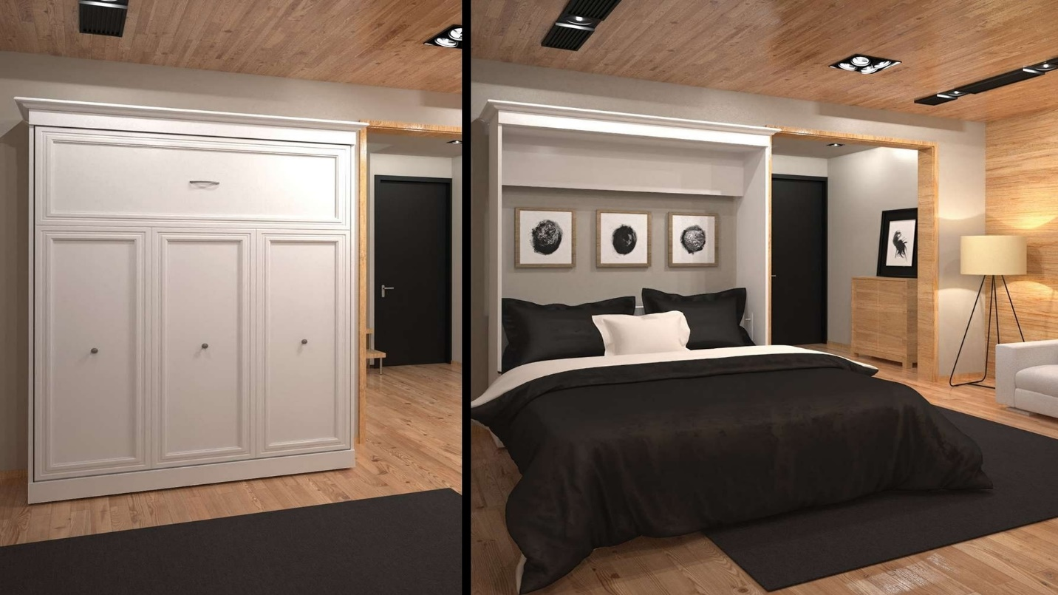

|  |  |
| --- | --- |
| **Title** | Folding Queen Wall Bed |
| **Size** | 2.1 m long ; 1.8 m wide; 1.9 high |
| **Weight** | 132 kg |
| **Price** | $1,100.00 |